Tab 1

Findings and Notes
Recording: https://fathom.video/calls/367738157

Questionnaire Forms

Intake forms

Data structure
Each vertical will have a “main” Patient Intake form, that some clients may want to modify to some degree. However, a minimum set of information must be available from the form. Tonda has a doc on this: https://docs.google.com/spreadsheets/d/1PqM_kAzApaUb-ie5QtOEO-42XwPceoF5gybyo0WjF6s/edit?gid=1703601219#gid=1703601219

FHIR concepts
- “Main” Patient Intake Questionnaire outline:
  - Convert Tonda’s doc into a series of QuestionnaireItems on the Questionnaire resource
  - Each QuestionnaireItem should include a `code`
  - If a client decides to modify the question asked but not the response content (i.e. convert “What is your weight goal?” -> “What is your dream weight?”), they can change the `text` of the QuestionnaireItem, and leave the `code` untouched
  - Then, when the QuestionnaireResponse is parsed, as long as the `code` matches, your automation should know how to parse this particular response

Discussion
- Clients who want complete control over their patient intake experience:
  - Some clients might want to have complete control over their patient intake experience. This might mean that they are not simply modifying the wording of the “main” Patient Intake questions, but choosing to get information from outside sources.
  - In this case, Medplum recommends that Openloop’s clients structure their intake response in some manner of their choosing, and come up with a mapping of that information to the verticals’ Main Patient Intake Questionnaire to validate that required information is available
  - When patient information is collected, this mapping will be used to log a QuestionnaireResponse in Openloop, which will then propagate the same way that QuestionnaireResponses on Openloop’s form would

Charting forms

Data structure
Each client within a vertical might have a different set of information when charting. For example, some clients want their patients to be prescribed only drugs from list [X,Y,Z], while other clients might want their patients to be prescribed only drugs from list [I,J,K]. While most of the “charting” experience stays in the vertical, options inside the charting questionnaire should vary.

Agenda
- Show-and-tell two different clients in the weight loss vertical. Walk through relevant UI screens and choices for one client. Then, walk through second client and explain differences between the two.
- Map templated resources to hierarchy (see Organization Hierarchy below)
- Go over access questions

Prerequisites
- Read Multi-tenant MSO

Deliverable for this session
- Create a hierarchy of organization levels: Across Openloop, By Vertical, By Client Type, By Client
- Map CarePlan/Questionnaire templates to levels in the organization hierarchy

Action Items
- Implement the two customers’ organizations and questionnaires into the above mapping

Outstanding Questions
- Care pathways focus -> clients can have many different focuses,
- Integrations and interactions with your backend
- Delineating two “episodes of care” for the same patient, how to model encounters relevant to both episodes of care

Information regarding Multi-Tenancy

Two facets to multi-tenancy:
- What templates are shared across tenants, and what customizations need to be made at sub-organization level?
- What patient information should be available for providers? To clients/patients? To clinical ops staff?

FAQs:
- How do we ensure that patient-related information is segmented to its organization?
  - See “Enrollment of a Patient into an Organization”: https://www.medplum.com/blog/multi-tenant-mso#organizationally-contained-access-restrictions
  - In order to change the Patient’s compartments, use $set-accounts: https://www.medplum.com/docs/api/fhir/operations/patient-set-accounts

Organization Hierarchy
What templates need to be available at what levels of the organization hierarchy? Do clients cross the hierarchy levels?

At each level, how much is this set up automatically, and how much is it set up by a member of Openloop?

Hierarchy Levels:

Level 0: (?) All OpenLoop

Level 1: Across Vertical
- Patient intake forms are standard at the base data level for all clients in a vertical
  - For each vertical, we define a set of keys that are needed for the clinical protocol
Level 2: (?) Across Types of Client

Level 3: For One Client
- G-Plans has their own intake forms

- Don’t do much work for insurance, mostly self pay
- Some variation of

Authentication and Access
- Patient information will be written to the client organization regardless of overarching auth structure
- However, we want to build an auth/access plan with as much as restriction as is necessary, and as little overhead as possible

1) Provider Auth
- Should providers have access to patient information at the vertical level, or at the client level? API or UI level?
- Grant providers access at a per-client basis

2) Client Auth
- Do you want your clients to be able to access data for the patients they have referred to Openloop?
- Clients integrate with Healthie, scoped within their sub-org
- Currently have write/delete access,
- Patient Acquisition/Intake is what they need to write/delete for
- With Medplum: need read/write to questionnaireresponses, just read to patient data (to be enumerated), no access to other info
- Complexity of implementation (for non technical clients):

3) Patient Auth
- Do you want individual patients that have used your services to be able to access their data?
- Currently obscured away from patients directly
- Clients have patient portals and patients can interact with client’s api keys
- Appointment scheduling access - patient access is a little more

4) Clinical Operations Auth
- Are there separations of clinical ops teams by vertical, client, function (billing, prescribing, etc)? Do clients bring their own clinical ops?
- Should clinical ops staff have access to all patient information, or a subset of anonymized patient information?
- Small centralized ops team that manages across clients/programs
- Clinical ops team are specialized
  - Scheduling team - manages scheduling across all customers

5) Partner access

Fathom summary

Workshop Day 1 (Client Onboarding)- Openloop|Medplum - July 31

VIEW RECORDING - 64 mins (No highlights)

Meeting Purpose
Workshop to discuss OpenLoop's client onboarding process, focusing on intake forms, charting, and overall system architecture for their telehealth platform.

Key Takeaways
- OpenLoop is transitioning from client-specific implementations to a more standardized, scalable approach across verticals and care pathways
- A new intake form builder is being developed to balance client customization with OpenLoop's data requirements
- Charting processes need modularization and standardization while maintaining flexibility for different care pathways
- Authentication and access control strategies are being refined for providers, clinical ops, clients, and potentially partners

Topics

Current System Limitations
- Existing setup is not scalable, with client-specific implementations causing maintenance challenges
- Intake forms vary widely between clients, making standardization difficult
- Charting forms are client-specific, leading to inconsistencies and difficulty in updates
- Limited data structure for intake responses, often stored as text blobs

New Intake Form Strategy
- Developing a no-code form builder for clients
- Will enforce mandatory fields while allowing customization
- Aims to standardize data collection across clients
- Challenge remains with larger clients who may require more control over intake process

Charting Improvements
- Goal to modularize charting experience
- Standardize UI but allow for client-specific content (e.g., medication options)
- Implement care pathways to dictate required tasks and presented modules
- Explore configuration-driven approach for clinical ops to manage options without engineering involvement

Authentication and Access Control
- Providers: Access limited to specific clients' patients within their vertical
- Clinical Ops: Currently have broad access, considering more granular controls
- Clients: Need defined schema for data exchange, considering read-only access to specific data
- Patients: Authentication exists but not actively used; considering future implementation
- Partners: Exploring integration possibilities for labs, sleep apnea companies, etc.

System Architecture Vision
- Moving towards multi-tenancy and extensibility
- Aim to support multiple care pathways per client (currently 5-7, potentially scaling to 20-30+)
- Focus on clinician productivity and ability to integrate with external systems
- Transition from code-driven to data-driven setup for more flexible configuration

Process Mapping and Pain Points
- Comprehensive end-to-end process map created, from provider application to medication shipping
- Identified pain points in current workflows, particularly in scheduling and medication management
- Need to address these issues in new architecture to improve efficiency and scalability

Next Steps
- Schedule detailed review of process map and pain points with Medplum team
- Continue development of intake form builder, aiming for September launch
- Proceed with provider interviews for UX insights on charting simplification
- Medplum to provide guidance on modularizing medication selection across customers in the same vertical
- Explore configuration-driven approach for managing client-specific options in charting forms

Action Items
- Send offline message to Tonda to schedule walkthrough of new intake form builder screens - WATCH (5 secs)
- Prepare guidance on modularizing selection menu across customers in same vertical for customizing provider options - WATCH (5 secs)
- Continue efforts to set up clinician interviews for UX insights, targeting completion by Tuesday - WATCH (5 secs)
- Review Jamie's OpenLoop end-to-end process map (Miro board) when access is granted - WATCH (5 secs)

Tab 2
Show-and-tell two different clients in the weight loss vertical. Walk through relevant UI screens and choices for one client, and walk through second client and explain differences between the two.

- G-Plans
  - https://clinic.openloophealth.com/healthie-orgs/8399/patients/4874360/charting-notes/45484810/edit
  - Metformin Offering
    - Metformin option on Labs will be ordered through: that leads to a ticket to manually order through quest - outdated and should be moved to ordering through Junction but exists this way still because this is the only client that offers this
  - Smart intake fields mapped directly onto form
    - Legacy remnant here due to this client using a custom intake form. We now mostly use a standardized form in the master org that allows us/clients to drop in a json payload of questions/answers
  - Medication ordering
    - Notes:
      - This is pretty much comprehensive list of all MWL meds we offer
    - 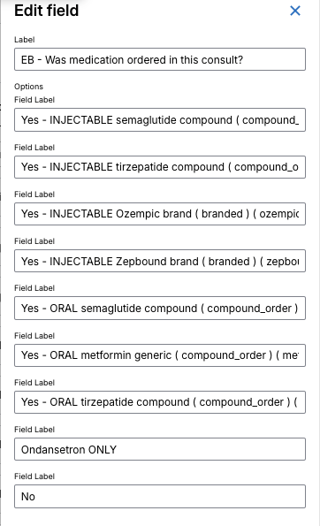
- Fridays
  - https://clinic.openloophealth.com/healthie-orgs/8602/patients/7620473/charting-notes/34034310/edit
  - Lab ordering
    - Not implemented with Junction automated lab ordering
  - Medication ordering
    - Notes:
      - Previously did 12 week ordering
    - 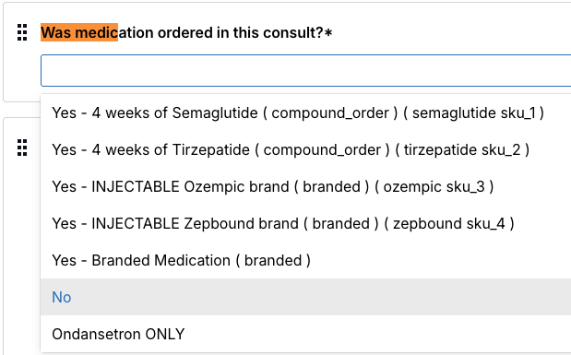

- TrimRx
  - https://clinic.openloophealth.com/healthie-orgs/78789/patients/7905836/charting-notes/35552039/edit
  - Medication ordering
    - 